# Task

* Download & Convert Flat Files to Microsoft SQL Server 2014+
* Create & Document Appropriate schema for database
* Automate this process using language of choice (c#, python, etc)
* Run it monthly to update current database with new records or updated records without having to dump the entire database and recreate.

# Flat Files that need to be converted

* <http://www.imdb.com/interfaces>
* <ftp://ftp.fu-berlin.de/pub/misc/movies/database/>
  + SKIP “diffs” folder.

# Example Python Project

* <http://imdbpy.sourceforge.net/>

This project is open source and converts the files we need. It says it supports MS SQL, but only on create. You can use this as an example on how/what needs to be done.

I wasn’t able to get this to properly work for MS SQL. It also didn’t convert ALL files.

CONTINUE TO PAGE 2

# Documentation

* I will require MS SQL Database documentation on how the schema is built and relationships/keys.
* Here is an example:

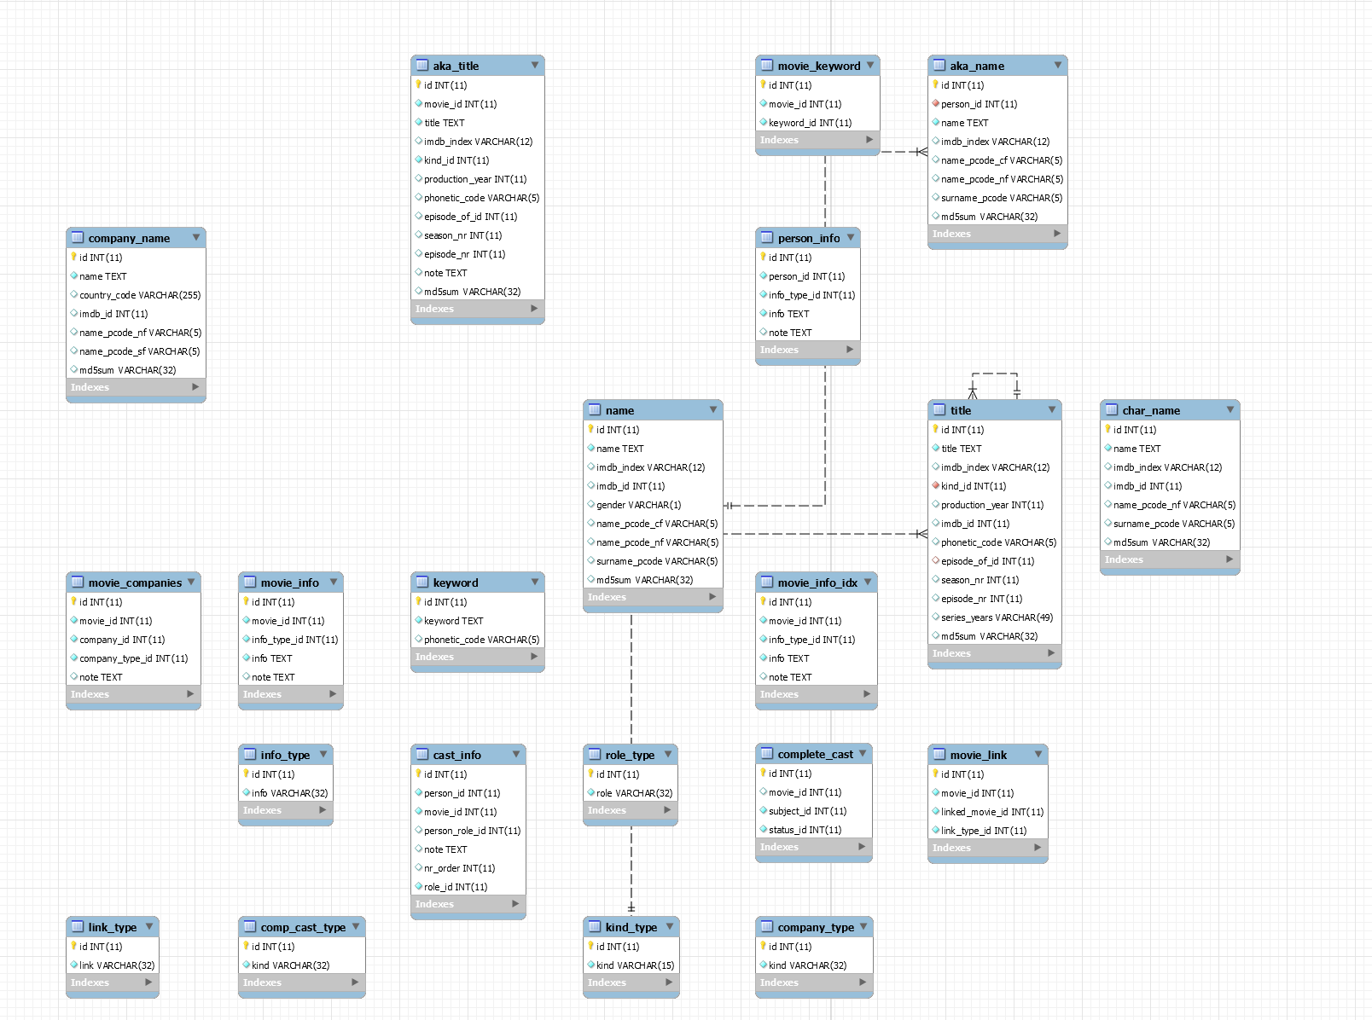

I will also require documentation on how to run the program/script for initial use and for updating the database when new files are downloaded.